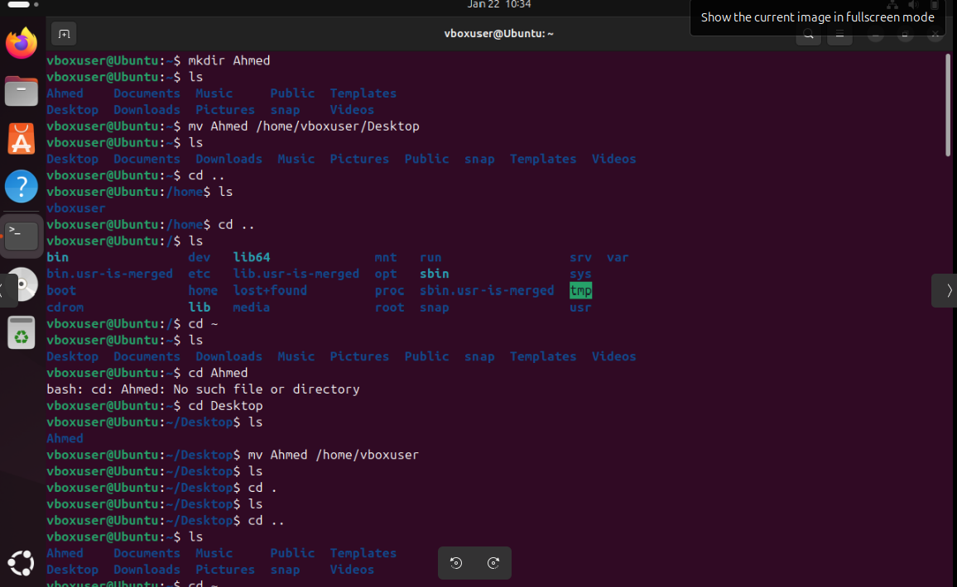

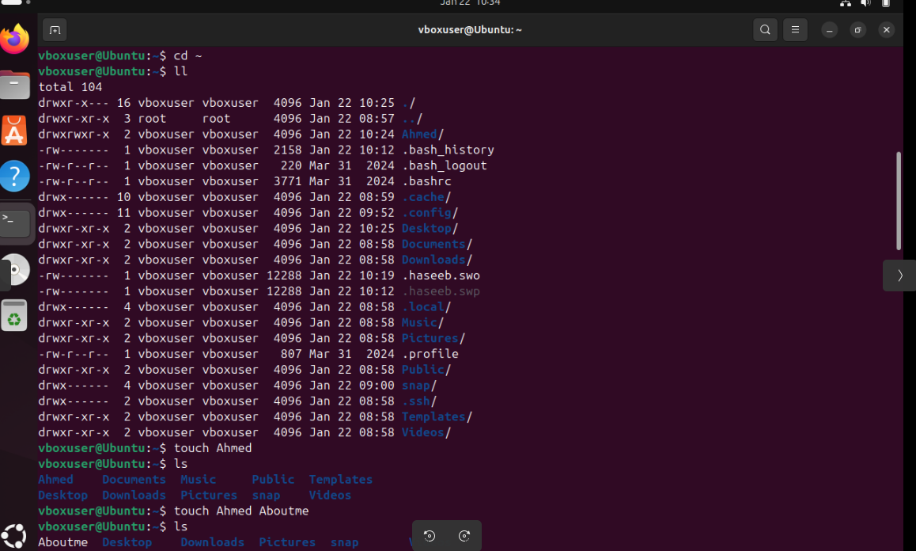

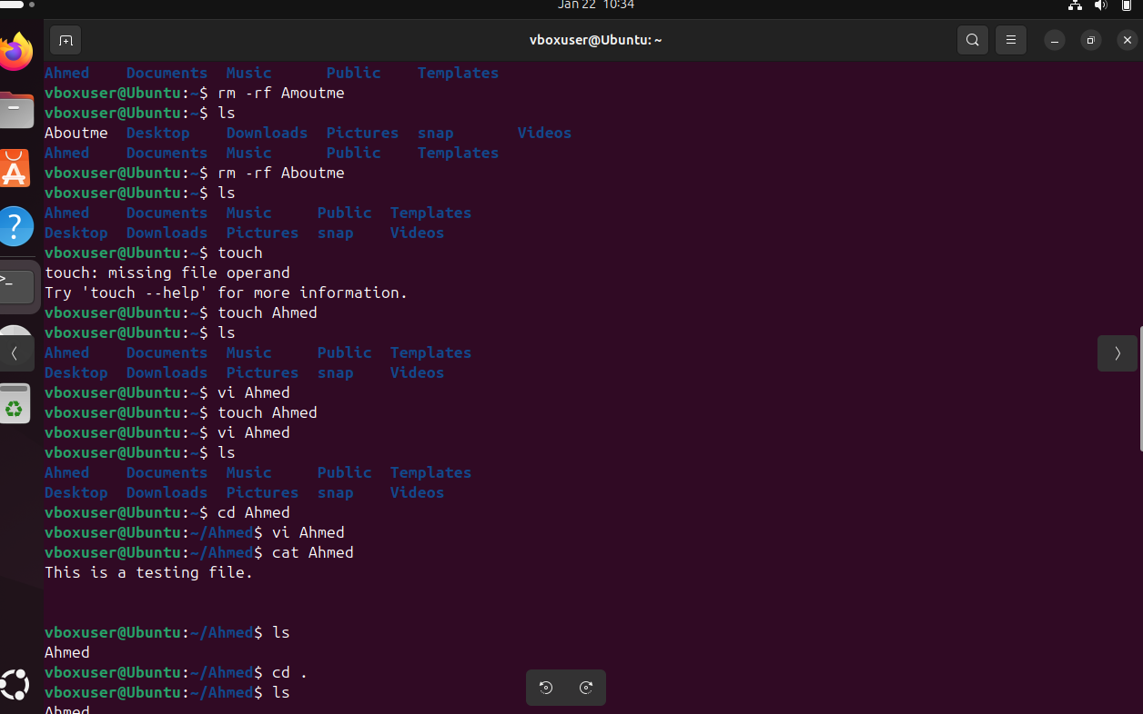

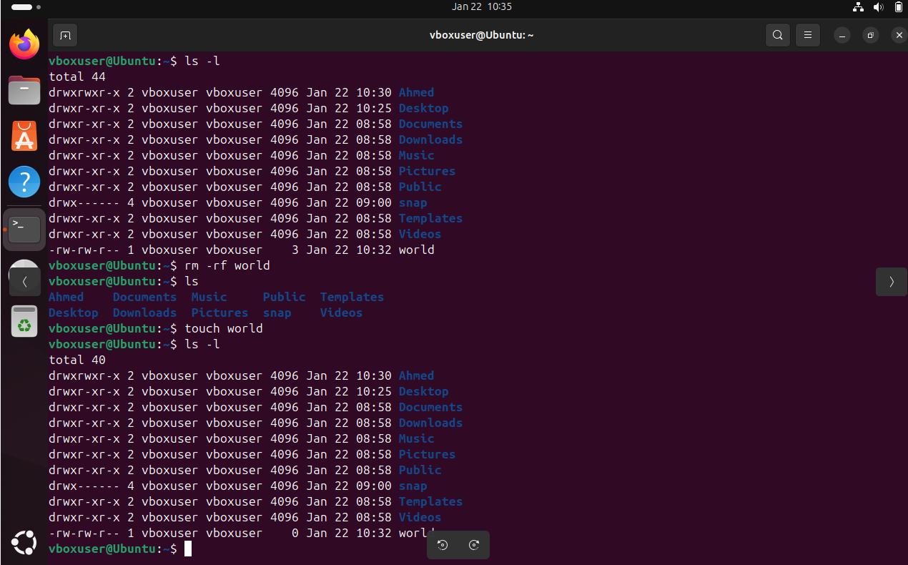

Linux is one of the operating system mainly use for coding. It is a free sourcing O.S means it doesn’t require any license to operate unlike Windows
It is a very secure O.S and it allows multiple user to access at the same time, whereas the windows o.s doesn’t allow the user to login with same credential at the same time.
Few commands are
~ :- It is used to go back to the root page
CD:- change directory/check
/ :- root directory
LS:- list of files
LL:- long list
MV :- moving of directory
MKDIR :_ Create a directory
PWD :- To check in which directory we are in
CD .. :- to go back two steps
CD. :- to go back on previous step
../.. use this to go back two steps before at once.
LS -a to see the hidden files
. File name:- To hide the file
CP file name :- to copy the file name
Rm -rf to delete the directory.

